**SEPERATION OF DUTIES (AC-5)**

* Making sure that security personnel installing access control, does not have access to audit functions.
* Performing information system support functions with different authorized users , such as configuration management, programming, etc.
* By separating duties and checking them with different authorized users, checks and balances .
* No single authorized users will have access, various personnel will be checking the system.
* By separating duties, organization reduces the chances of misusing authorized privileges.

**USERS  
  
In Users we have created Maintenance Admin, Database Designer and User Admin and given them their respective grants and privileges.**

**Creating 5 Users**

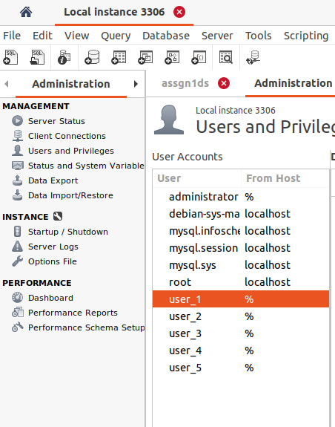

**User Admin**User Admin will construct databases for storing data and allowing users to interact with it. **SCHEMA PRIVILIGES**  
  
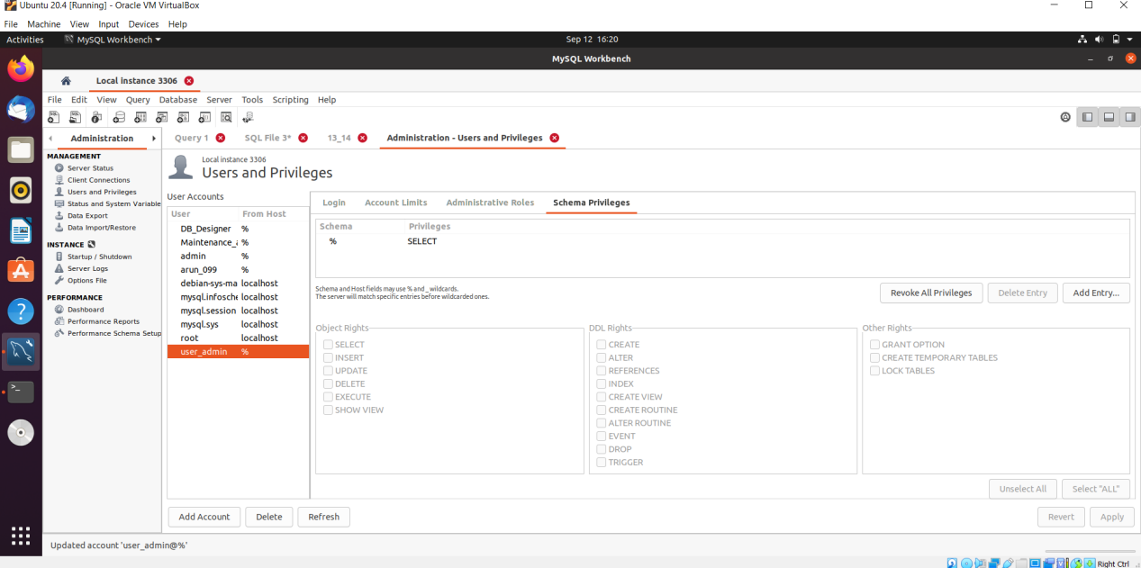

**ADMINISTRATIVE ROLES**

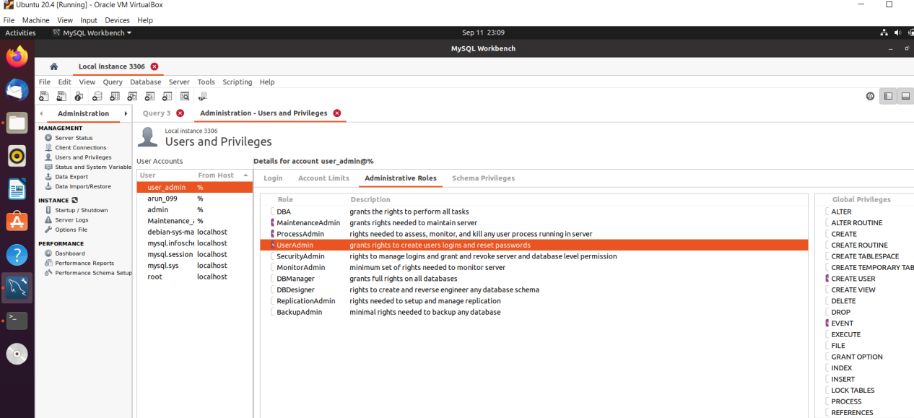

**ACCOUNT LINKS**

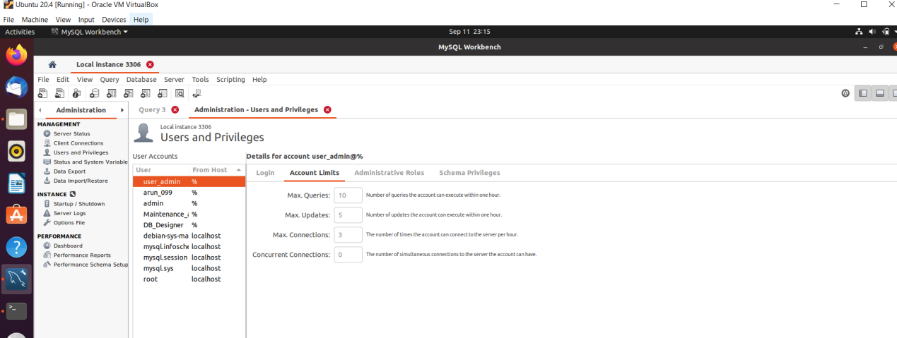

**User_1**  
**Account Login**

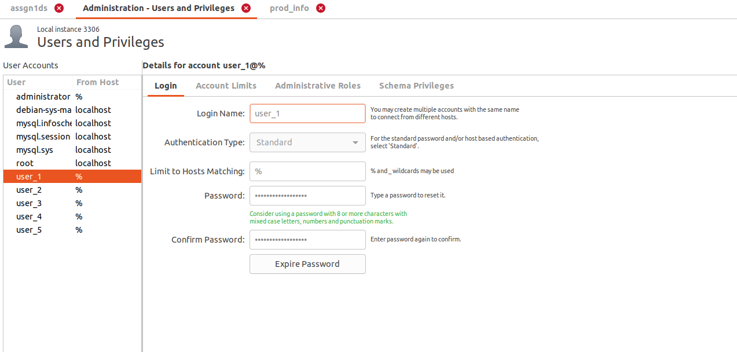

**SCHEMA PRIVILIGES**  
  


**ADMINISTRATIVE ROLES**



**ACCOUNT LINKS**



**User_2**

**Account Login**  
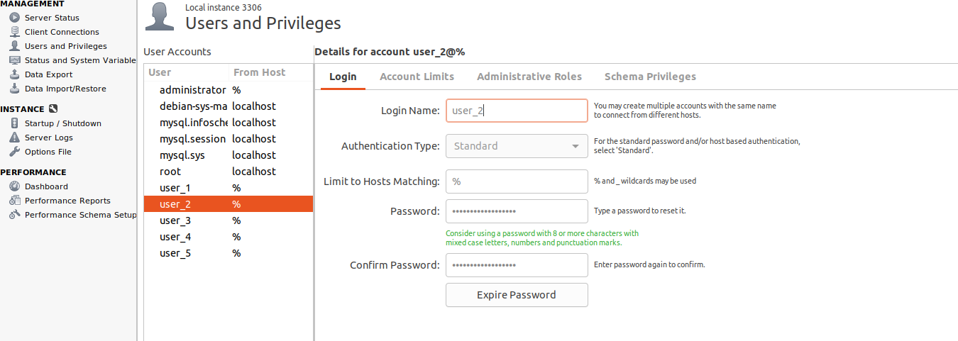

**SCHEMA PRIVILIGES**  
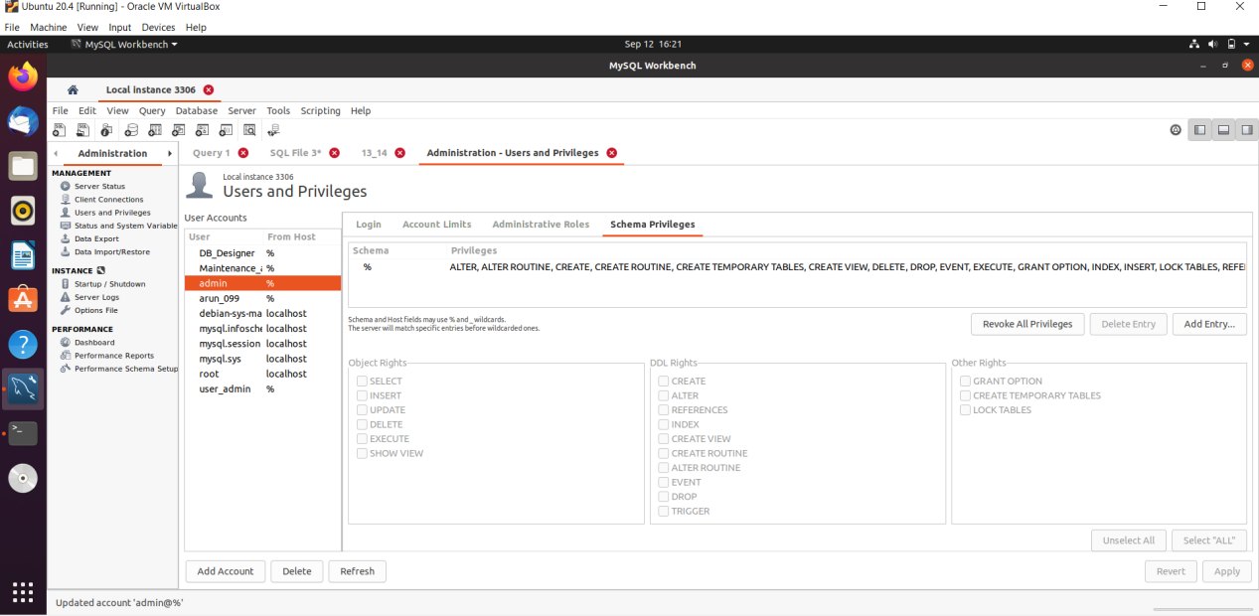

**ADMINISTRATIVE ROLES**

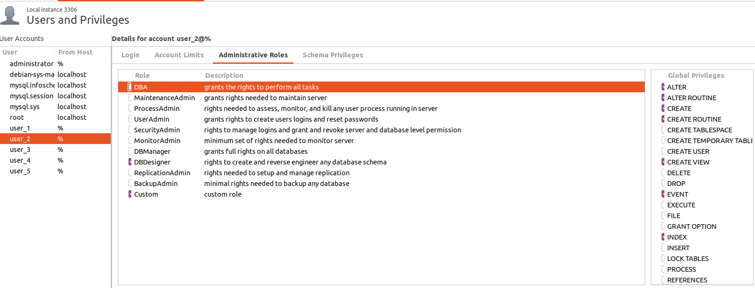  
 **Account Links**

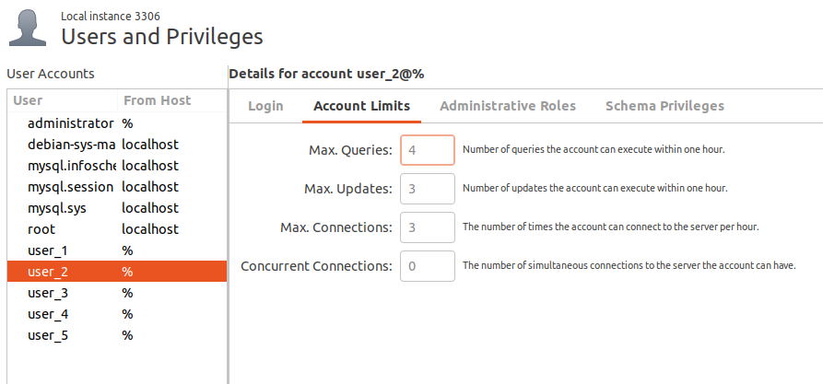  
  
**User_3**

**Account Login**

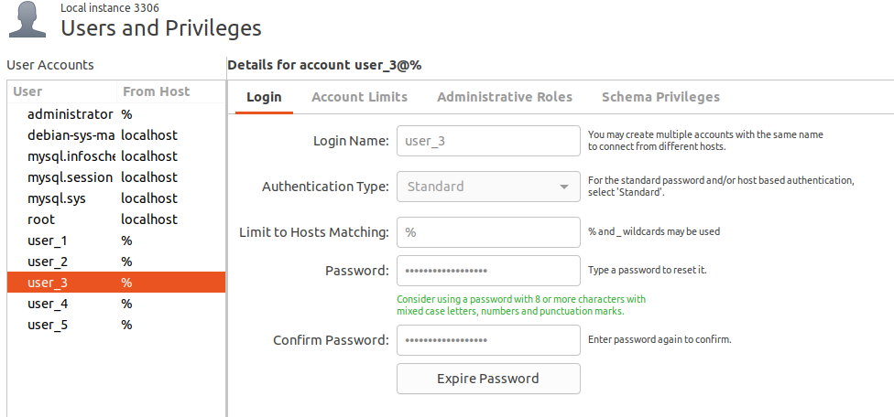  
**Account Limits**  
  
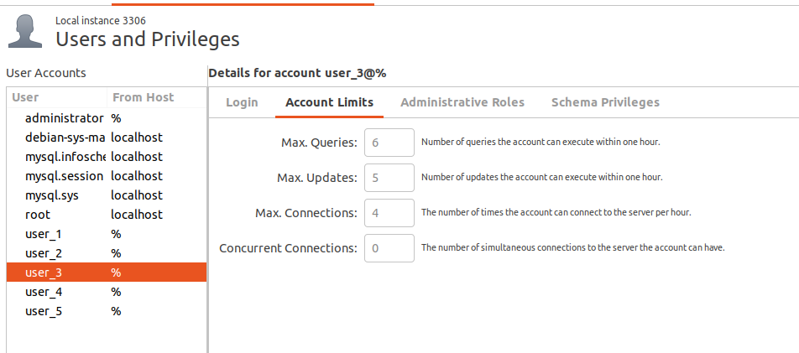

**Administrative Roles**

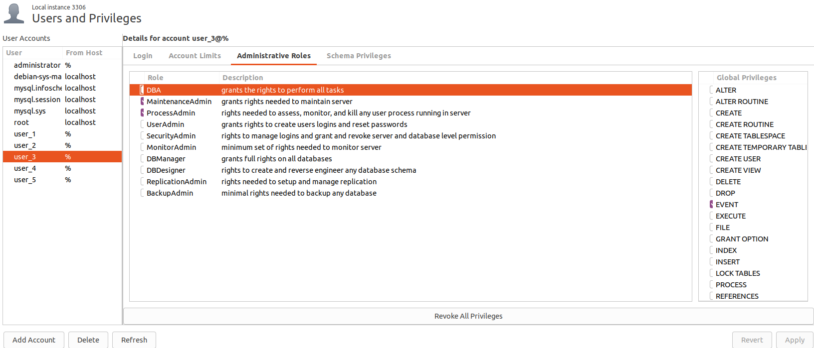

**Schema Privileges**

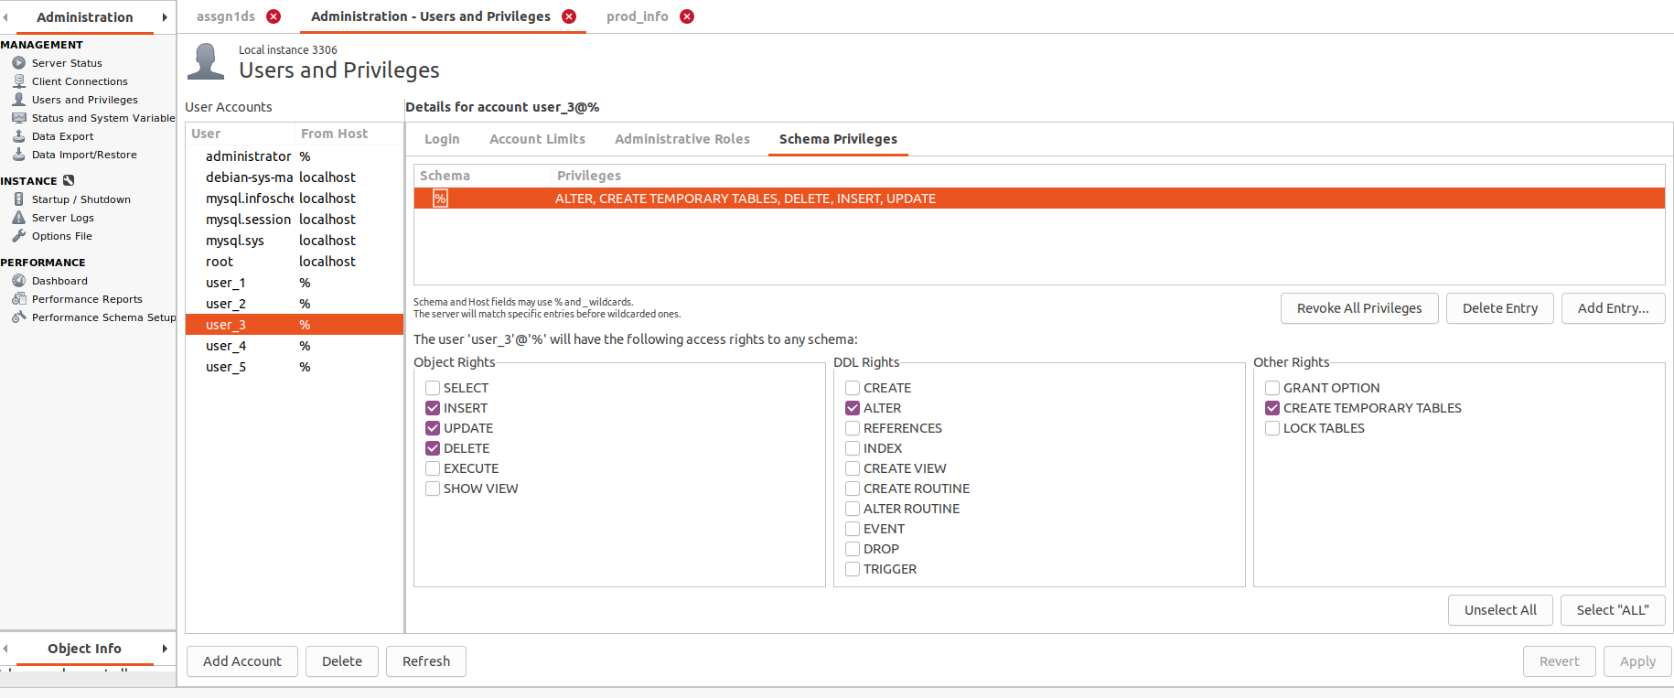  
  
**User_4**

**Account Login**

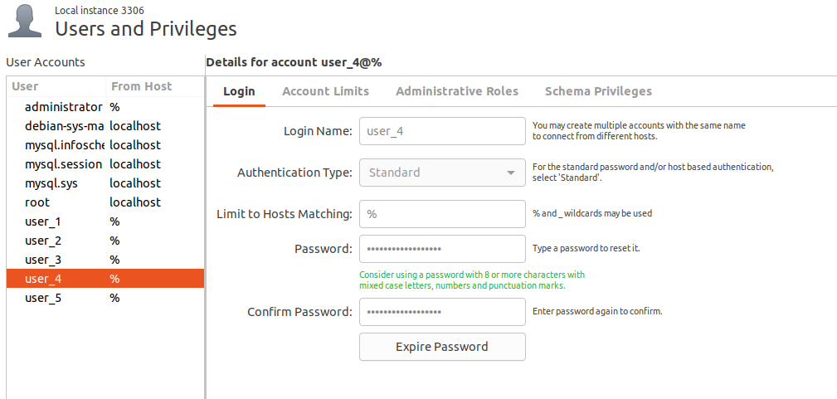  
**Account Limits**  
  
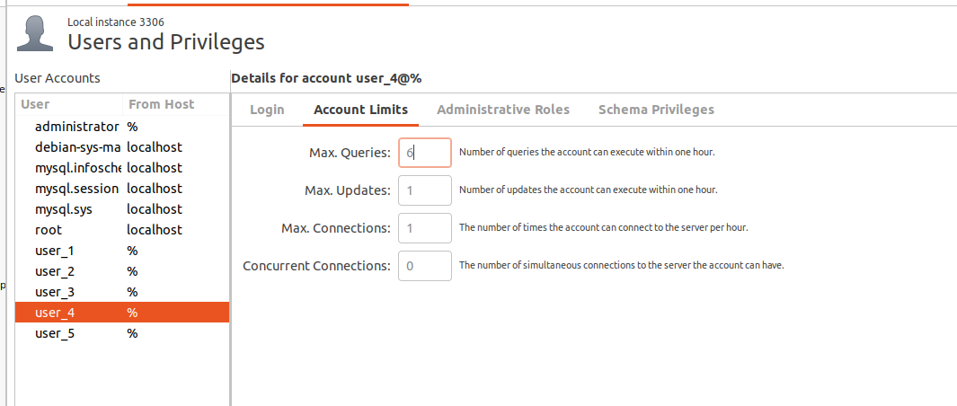

**Administrative Roles**

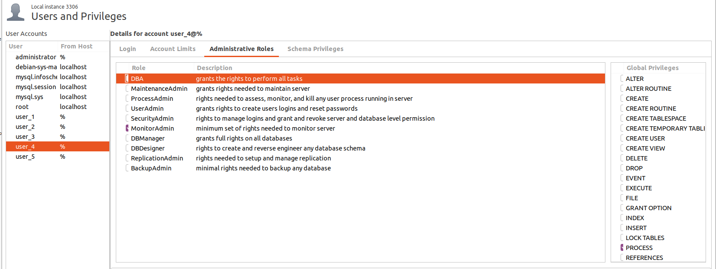

**Schema Privileges**

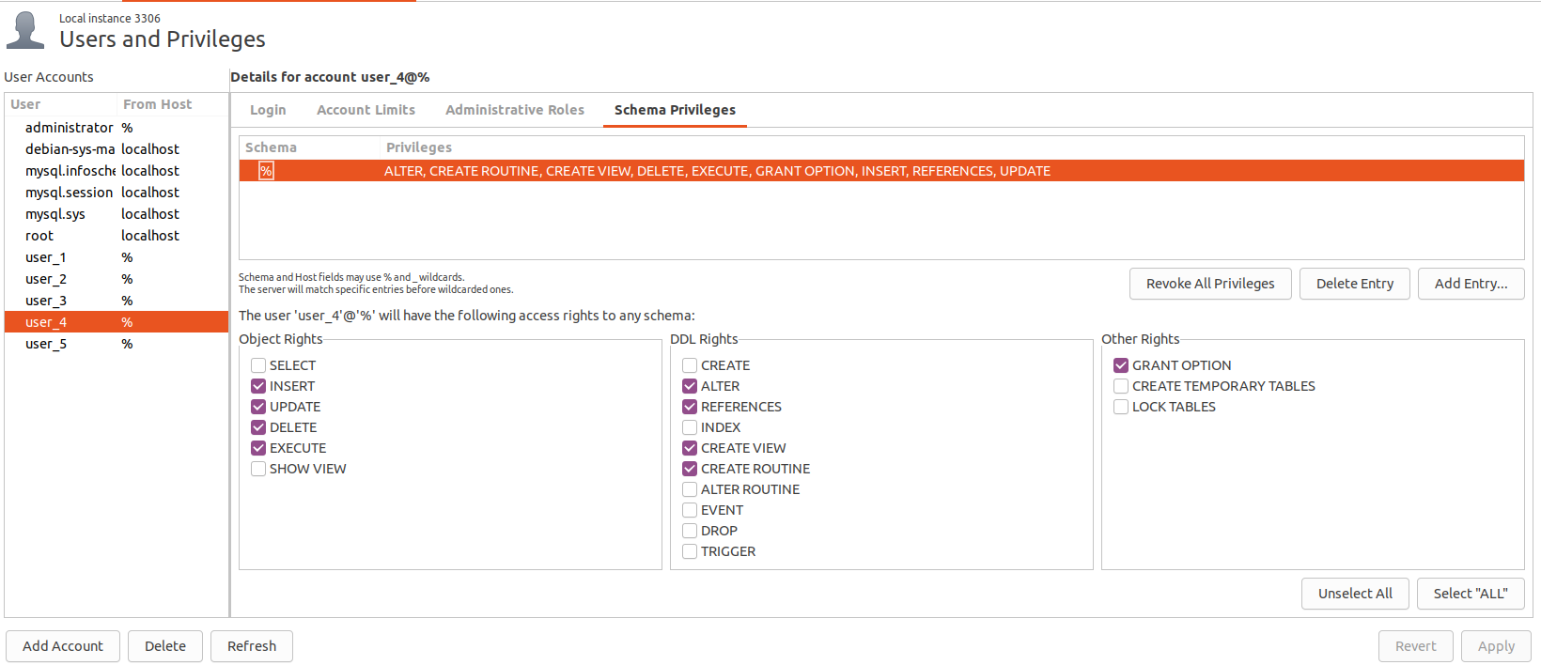

**User_5**

**Account login**

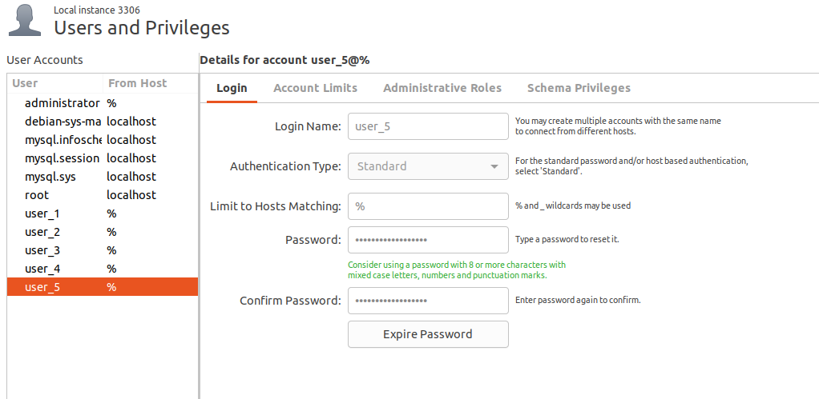

**Account Limits**

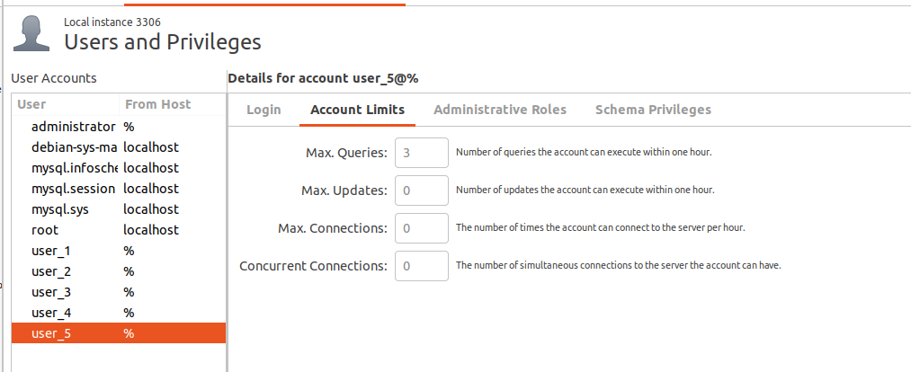

**Administrative Roles**

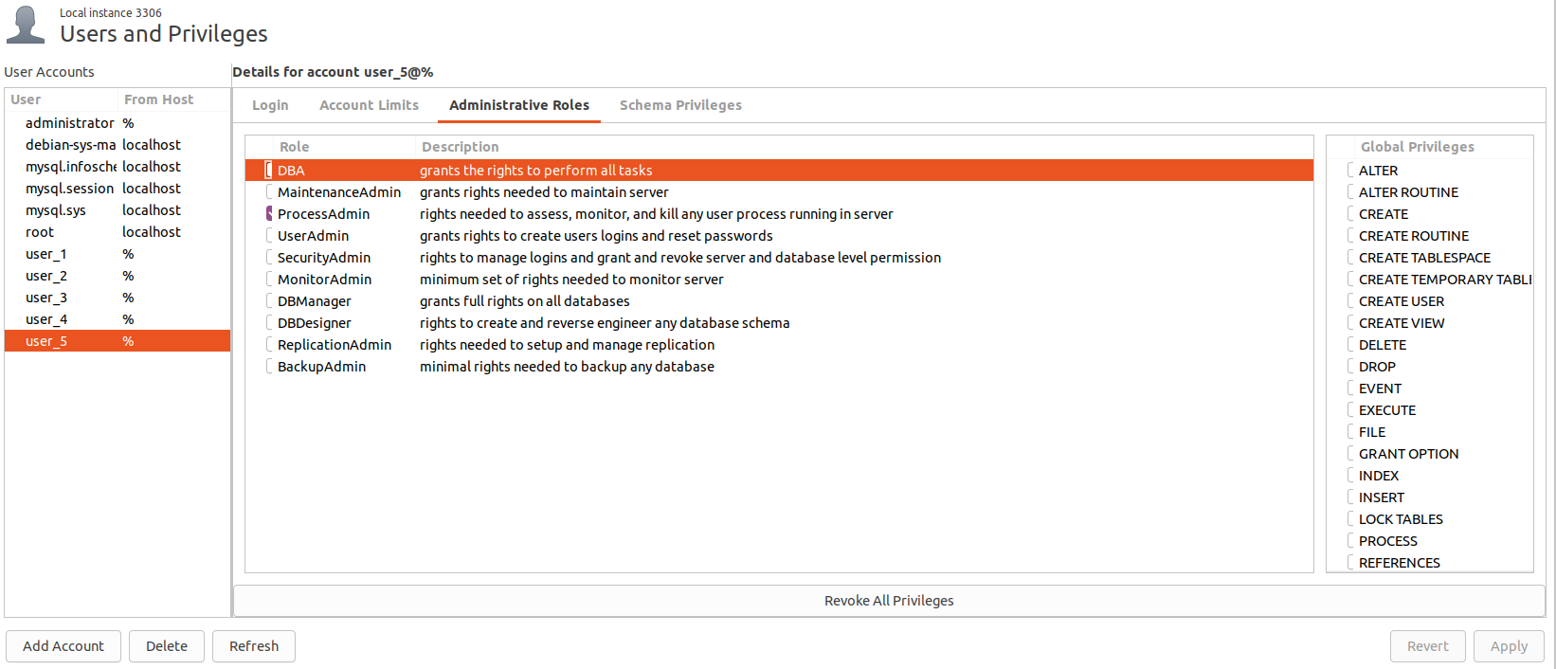

**Schema Privileges**

